DIY ESP32 Lux Meter (TSL2591): Build Documentation
Oct 9, 2026 · @geto

1. Project Overview
This prototype is a DIY lux meter: an ESP32 reads a TSL2591 light sensor over I2C and reports illuminance in lux on the Serial Monitor, with an optional OLED readout.
Idea. Replace a low-cost light-dependent resistor (LDR) setup with a digital sensor that has a built-in ADC, so readings are in lux without hand-built conversion circuits.
Prototype goals
- Read lux from the TSL2591 and print it over USB serial.
- Handle a wide range of lighting (dim room to bright daylight) by adjusting sensor gain automatically.
- Optionally show the value on an SSD1306 OLED.
- Optionally send readings to a laptop over Bluetooth.
- Check the readings against a reference lux meter and apply a correction if needed.
Out of scope for this prototype: custom PCB, enclosure design, battery management, and reference-grade certified accuracy.
Open question: the intended use (bench-only, portable field device, or data logger) has not been stated. Steps 1 to 3 below apply to all three; steps 4 and 5 are optional.
Verification status: [Unverified] Sensor facts were checked against Adafruit's pages, but the code has not been compiled or run, and several other items are labeled unverified where they appear. Section 9 lists what is and is not checked.

2. System Design
The TSL2591 measures light; the ESP32 reads it over I2C, converts the raw counts to lux, and sends the result to the outputs you choose.
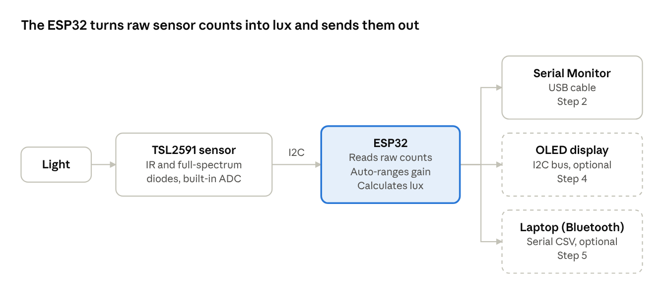
system block diagram · 3 stages, 2 optional outputs
The ESP32 also sets the sensor's gain over the same two I2C wires. The OLED and Bluetooth outputs are optional (dashed).
How lux is derived. Per Adafruit's overview, the TSL2591 has an infrared photodiode, a full-spectrum photodiode, and a built-in ADC. The library's calculateLux(full, ir) combines the two channels with the current gain and integration time, using a formula from the chip vendor that Adafruit describes as a rough match to SI lux.
Why this sensor. Adafruit lists a 600,000,000:1 dynamic range, about 0.4 mA when sensing, and under 5 µA in power-down; its stated range is about 188 µlux to 88,000 lux (see the verification notes in section 9). [Inference] That wide range is the reason to prefer it over the BH1750 for a meter used in both dim and bright conditions.

3. Bill of Materials
Five items make a working lux meter; everything else depends on how you plan to use it. This list mirrors the parts list spreadsheet, with the TSL2591 as the sensor. Prices are left out because they depend on the supplier you choose.
Item | Qty | Required? | Notes
ESP32 DevKit board | 1 | Yes | Any board that exposes the I2C pins. [Unverified] Pin labels differ between board makers; check yours.
TSL2591 light sensor breakout | 1 | Yes | Adafruit sells a STEMMA QT version and a header-only version; its guide says the code works the same on both.
Breadboard | 1 | Yes | For prototyping before any soldering.
Jumper wires | 4 per I2C device | Yes | Power, ground, SDA, SCL.
USB cable (data-capable) | 1 | Yes | Powers the board and uploads code; a charge-only cable will not upload.
SSD1306 OLED, 128x64, I2C | 1 | Optional | Standalone display; shares the same two I2C lines.
Push buttons (4-pin tactile) | 2 | Planned | One for hold, one for mode; use the diagonal legs of each.
LiPo battery + TP4056 charger | 1 each | Optional | Portable use only. Battery management is outside this prototype.
5V boost converter module | 1 | Optional | Portable use only. [Inference] Raises the TP4056 output to 5V for the ESP32 VIN pin; a single LiPo cell is likely too low to run the board directly.
Enclosure | 1 | Optional | Leave an open window over the sensor.
4.7 kΩ pull-up resistors | 2 | Board-dependent | [Unverified] I could not confirm whether your specific breakout already includes I2C pull-ups; check the board or its datasheet before adding any.

4. Wiring
The sensor and the optional OLED share one I2C bus, so only four wires run to the ESP32. The TSL2591's I2C address is fixed at 0x29 and cannot be changed, per Adafruit's pinout page; [Unverified] SSD1306 modules usually use a different address, so they should not collide with the sensor, but I have not confirmed your module's address; the I2C scanner in step 1 will show it.
TSL2591 pin | ESP32 pin | Notes
VIN | 3V3 | Adafruit says to power the board at your microcontroller's logic voltage. [Inference] ESP32 logic is 3.3 V, so 3V3 is the match.
GND | GND | Common ground.
SDA | GPIO 21 | [Unverified] Commonly the default I2C data pin on ESP32 DevKit boards; confirm on your board's pinout.
SCL | GPIO 22 | [Unverified] Commonly the default I2C clock pin; confirm as above.
3Vo | not connected | 3.3 V regulator output; not needed here.
INT | not connected | Interrupt output; not used in this prototype.
The optional SSD1306 connects to the same 3V3, GND, GPIO 21 (SDA) and GPIO 22 (SCL) lines.
Checklist before powering on
- ☐ Sensor VIN goes to 3V3, not 5V.
- ☐ SDA goes to SDA and SCL to SCL on every device (not crossed).
- ☐ All grounds are common.
- ☐ The sensor window is uncovered and not shadowed by wires.

Full wiring map (sensor, OLED, button, Bluetooth link)
This map extends the sensor wiring above to the optional parts. Dashed boxes are optional; a dot marks a join, and a wire crossing without a dot is not connected.
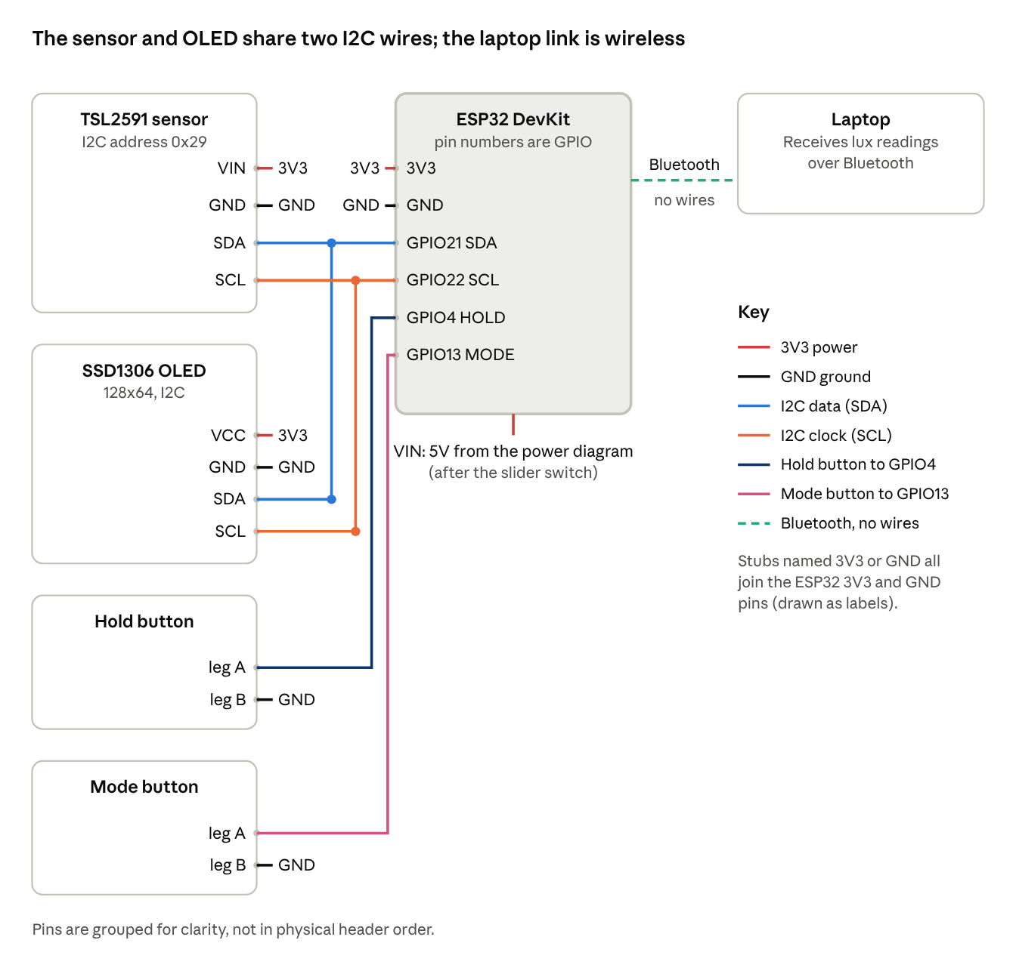
full wiring map · ESP32, TSL2591, OLED, button, Bluetooth link to laptop
- [Unverified] Bluetooth is built into the ESP32, so it needs no wiring. The sketches in this document do not send data over Bluetooth yet; that code is still to be written.
- Two 4-pin push buttons, each wired between a GPIO pin and GND: Hold on GPIO 4 and Mode on GPIO 13. Use two diagonal legs of each button. [Unverified] Some 4-pin buttons are wired differently; check with a multimeter in continuity mode that the two legs connect only while the button is pressed.
- [Unverified] GPIO 4 and GPIO 13 are general-purpose pins that I believe are not boot-strapping pins on the ESP32; confirm on your board's pinout.
- Hold freezes the reading on the screen; Mode cycles the LUX, MIN/MAX and RAW screens, and holding Mode for 1.5 seconds resets min/max. The code is esp32_lux_oled_buttons.ino. The buttons do not control power; the slider switch does.
- Run the I2C scanner (step 1) to confirm the OLED address before relying on 0x3C.

Power from a battery, with a slider switch (optional)
This path is only for portable use. [Inference] A single LiPo cell is likely too low a voltage to run the board through its VIN pin directly, so the map adds a boost converter set to 5V. It is listed in the bill of materials in section 3.
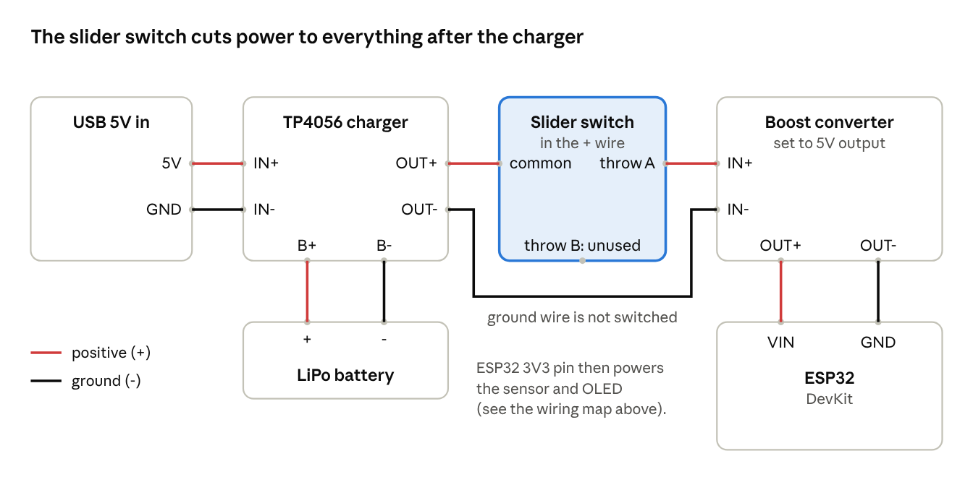
portable power path · USB, TP4056, LiPo, slider switch, boost converter, ESP32
- Slider switch: wire the middle pin (common) to the TP4056 OUT+ and one outer pin to the boost converter IN+. Leave the other outer pin empty. [Unverified] Pin order differs between slider switches; check with a multimeter in continuity mode that the common pin connects to an outer pin in only one slider position.
- [Inference] The switch sits after the charger, so the battery can still charge from USB while the switch is off. Only the positive wire is switched; ground stays connected.
- [Unverified] I have not looked up the switch's current rating or how much current the ESP32 draws with Bluetooth on; check the switch is rated above it.
- [Inference] Do not wire the battery straight to the ESP32 3V3 pin; a charged LiPo cell sits above 3.3V.
- [Unverified] Pad names (IN+, OUT+, B+) vary between TP4056 boards. Prefer a version with a protection chip for a bare cell, and check polarity before connecting the battery.
- [Inference] Avoid powering the board from USB and the boost converter at the same time unless your board is built to handle it.

5. Software Environment
The code in this document targets the Arduino IDE with the ESP32 board package. [Speculation] PlatformIO may also work, but this document does not cover it.
- Install the Arduino IDE.
- In the Boards Manager, install the ESP32 package from Espressif. [Unverified] The exact menu path and board-manager URL depend on your IDE version; follow Espressif's current instructions.
- Select your board under Tools > Board. [Unverified] "ESP32 Dev Module" is a common generic choice, but the right entry depends on your board.
- Install the libraries below from the Library Manager.
- Set the Serial Monitor to 115200 baud. This is the rate the sketches below use; Adafruit's own example uses 9600, so match whichever you set in Serial.begin().
Library (Library Manager search term) | Needed for | Source
Adafruit TSL2591 Library | Sensor driver | Adafruit guide
Adafruit Unified Sensor | Dependency of the TSL2591 library | Adafruit guide
Adafruit SSD1306 | OLED driver (optional) | [Unverified] Name from memory; confirm in the Library Manager
Adafruit GFX Library | Graphics base for the OLED (optional) | [Unverified] Name from memory; confirm in the Library Manager
Wire.h ships with the ESP32 package, so it needs no separate install. [Unverified] I did not check this against the current package.

6. Build Steps and Code
Build in five stages, confirming each one works before adding the next. [Unverified] The sketches below use the library calls documented by Adafruit, but I have not compiled them or run them on hardware. Treat them as a starting point and expect to adjust.

Step 1: Confirm the sensor is on the I2C bus
Wire the sensor as in section 4, then upload this scanner. It lists every address that answers.
#include <Wire.h>
void setup() {
Serial.begin(115200);
Wire.begin(21, 22); // SDA, SCL
delay(500);
Serial.println("Scanning I2C bus...");
int found = 0;
for (uint8_t addr = 1; addr < 127; addr++) {
Wire.beginTransmission(addr);
if (Wire.endTransmission() == 0) {
Serial.print("Found device at 0x");
Serial.println(addr, HEX);
found++;
}
}
if (found == 0) Serial.println("No I2C devices found. Check wiring.");
}
void loop() {}
Expected: a device at 0x29. Adafruit's guide notes that 0x28 is also taken by the chip, so seeing both is not a fault. No devices found points to power, ground, or swapped SDA/SCL.

Step 2: Read raw channels and lux
This sketch reads the infrared and full-spectrum channels together, then converts them to lux with the library's calculateLux(full, ir).
#include <Wire.h>
#include <Adafruit_Sensor.h>
#include <Adafruit_TSL2591.h>
#define SDA_PIN 21
#define SCL_PIN 22
Adafruit_TSL2591 tsl = Adafruit_TSL2591(2591); // 2591 = sensor ID tag
void setup() {
Serial.begin(115200);
Wire.begin(SDA_PIN, SCL_PIN);
if (!tsl.begin(&Wire)) {
Serial.println("TSL2591 not found. Check wiring.");
while (1) delay(10);
}
tsl.setGain(TSL2591_GAIN_MED); // 25x
tsl.setTiming(TSL2591_INTEGRATIONTIME_100MS); // 100 ms
}
void loop() {
uint32_t lum = tsl.getFullLuminosity();
uint16_t ir = lum >> 16; // high word: infrared
uint16_t full = lum & 0xFFFF; // low word: IR + visible
float lux = tsl.calculateLux(full, ir);
Serial.print("IR: "); Serial.print(ir);
Serial.print(" Full: "); Serial.print(full);
Serial.print(" Lux: "); Serial.println(lux, 2);
delay(500);
}
Cover the sensor with a hand, then shine a lamp on it; the lux value should fall and rise. Adafruit's library reference says calculateLux returns a negative value on overflow, and its example treats a reading of 0 as probable saturation, although 0 can also be a truly dark room.
[Unverified] I do not know whether tsl.begin(&Wire) re-initializes the I2C bus internally. If readings fail after using non-default pins, test with tsl.begin() and the board's default pins.

Step 3: Add automatic gain ranging
A fixed gain clips in bright light and loses resolution in dim light. This sketch steps the gain through the four documented levels (1x, 25x, 428x, 9876x) based on the raw count.
[Inference] The thresholds below (30000 and 200 counts) are my own conservative design choices, not datasheet values. I did not verify the sensor's saturation count, so tune them on your hardware. They are spaced so a gain step up from the dim limit cannot land above the bright limit, which avoids flip-flopping between levels.
#include <Wire.h>
#include <Adafruit_Sensor.h>
#include <Adafruit_TSL2591.h>
#define SDA_PIN 21
#define SCL_PIN 22
Adafruit_TSL2591 tsl = Adafruit_TSL2591(2591);
const tsl2591Gain_t gains[] = { TSL2591_GAIN_LOW, TSL2591_GAIN_MED,
TSL2591_GAIN_HIGH, TSL2591_GAIN_MAX };
const char* gainName[] = { "1x", "25x", "428x", "9876x" };
int gainIdx = 1; // start at medium (25x)
const uint16_t TOO_BRIGHT = 30000; // raw counts: step gain down above this
const uint16_t TOO_DIM = 200; // raw counts: step gain up below this
const uint16_t SETTLE_MS = 120; // wait after a gain change
void applyGain() {
tsl.setGain(gains[gainIdx]);
delay(SETTLE_MS); // precaution: let a fresh integration cycle finish
}
// Returns true when lux is valid. 'saturated' is set if even 1x gain is too bright.
bool readLux(float &lux, bool &saturated) {
saturated = false;
for (int i = 0; i < 4; i++) {
uint32_t lum = tsl.getFullLuminosity();
uint16_t ir = lum >> 16;
uint16_t full = lum & 0xFFFF;
if (full > TOO_BRIGHT) {
if (gainIdx > 0) { gainIdx--; applyGain(); continue; }
saturated = true; // already at lowest gain
return false;
}
if (full < TOO_DIM && gainIdx < 3) {
gainIdx++; applyGain(); continue;
}
lux = tsl.calculateLux(full, ir);
return (lux >= 0); // negative = overflow per Adafruit docs
}
return false; // did not settle in 4 tries
}
void setup() {
Serial.begin(115200);
Wire.begin(SDA_PIN, SCL_PIN);
if (!tsl.begin(&Wire)) {
Serial.println("TSL2591 not found. Check wiring.");
while (1) delay(10);
}
tsl.setTiming(TSL2591_INTEGRATIONTIME_100MS);
applyGain();
}
void loop() {
float lux; bool sat;
if (readLux(lux, sat)) {
Serial.print(lux, 2);
Serial.print(" lux (gain ");
Serial.print(gainName[gainIdx]);
Serial.println(")");
} else if (sat) {
Serial.println("Saturated: too bright for this sensor setup");
} else {
Serial.println("No valid reading yet");
}
delay(500);
}
The 100 ms integration time is the shortest option; Adafruit's guide says longer times (up to 600 ms) increase sensitivity in dim light. If your target is very dark rooms, try a longer time once the rest works.

Step 4 (optional): Show the reading on an OLED
[Unverified] The OLED calls below come from my memory of the Adafruit SSD1306 and GFX libraries, not from a source I opened this session. Check them against the library examples if the sketch does not compile.
Add these pieces to the step 3 sketch. Call setupDisplay() at the end of setup() and showLux(...) from loop().
#include <Adafruit_GFX.h>
#include <Adafruit_SSD1306.h>
#define SCREEN_W 128
#define SCREEN_H 64
#define OLED_ADDR 0x3C // confirm with the step 1 scanner
Adafruit_SSD1306 display(SCREEN_W, SCREEN_H, &Wire, -1);
void setupDisplay() {
if (!display.begin(SSD1306_SWITCHCAPVCC, OLED_ADDR)) {
Serial.println("OLED not found. Check wiring and address.");
while (1) delay(10);
}
display.clearDisplay();
display.display();
}
void showLux(float lux, const char* gainLabel, bool valid) {
display.clearDisplay();
display.setTextColor(SSD1306_WHITE);
display.setTextSize(1);
display.setCursor(0, 0);
display.print("Lux meter gain ");
display.print(gainLabel);
display.setTextSize(2);
display.setCursor(0, 24);
if (valid) display.print(lux, 1);
else display.print("Range!");
display.setTextSize(1);
display.setCursor(0, 54);
display.print("lux");
display.display();
}
In loop(), replace the serial if block with showLux(lux, gainName[gainIdx], valid);, where valid is the return value of readLux(lux, sat). Keep the Serial prints too; they help when debugging.

Step 5 (optional): Send readings to a laptop over classic Bluetooth
The ESP32 appears to the laptop as a Bluetooth serial device named LuxMeter. Pair it in the laptop's Bluetooth settings, then open the COM port it creates in a serial terminal. Each measurement arrives as one CSV line: millis,lux,gain. [Unverified] BluetoothSerial.h is part of the ESP32 Arduino package as far as I know, and classic Bluetooth is not available on ESP32-S3 or C3 boards; I did not check this.
Merge it into the step 3 sketch: call SerialBT.begin("LuxMeter") in setup() and btSend() after each valid read. The finished version, with the OLED and both buttons, is lux_meter_bt.ino in the code package. [Unverified] The sketch has not been compiled or run on hardware; its button and Bluetooth logic was only run against stand-in libraries on a PC.
#include "BluetoothSerial.h"
BluetoothSerial SerialBT;
bool btWasConnected = false;
// call SerialBT.begin("LuxMeter"); in setup()
// call after each valid read; lux is the latest reading
void btSend() {
if (!SerialBT.hasClient()) { btWasConnected = false; return; }
if (!btWasConnected) { SerialBT.println("millis,lux,gain"); btWasConnected = true; }
SerialBT.print(millis()); SerialBT.print(',');
SerialBT.print(lux, 2); SerialBT.print(',');
SerialBT.println(gainName[gainIdx]);
}

7. Testing and Calibration
Compare your meter against a reference lux meter and correct any consistent difference in software. Adafruit describes the library's lux value as a rough correlation to SI lux based on the chip vendor's formula, so a check against a known meter is worth doing before you trust the numbers.
Open question: I do not know whether you have access to a calibrated reference meter. Without one, readings are relative, not absolute.
Procedure
- Place the reference meter and your sensor side by side, facing the same light source, at the same distance and angle.
- Take readings at five or more light levels, from dim to bright, using the light source you plan to measure.
- Record each pair in the table below.
- Fit a straight line through the points (see below) to get a scale factor and an offset.
- Put those two numbers in the sketch and re-test at one or two light levels you did not use for the fit.
[Inference] The correction may differ by light source (daylight, LED, incandescent) because the sensor's conversion uses two channels with different spectral responses. If you will measure several source types, calibrate for each or note the error.
Reference (lux) | Your meter (lux) | Notes
With the pairs in a spreadsheet, the SLOPE and INTERCEPT functions give the two constants, using the reference values as the known y and your meter's values as the known x.
\text{lux}_{cal} = a \cdot \text{lux}_{raw} + b

const float CAL_SCALE = 1.00; // a: replace with your fitted slope
const float CAL_OFFSET = 0.00; // b: replace with your fitted intercept (lux)
float calibrated = lux * CAL_SCALE + CAL_OFFSET;
If the fit is poor (points do not lie near a line), do not force one. Check for stray light, shadows, mismatched angles, and gain changes happening mid-reading.

8. Troubleshooting
[Inference] The causes below come from common I2C behavior and the saturation notes in Adafruit's guide; none were reproduced on your hardware. Work down the list in order.
Symptom | Likely cause | What to check
Scanner finds nothing | Power, ground, or SDA/SCL wiring | Re-seat jumpers; confirm VIN on 3V3; try swapping SDA and SCL; try a different jumper wire.
Scanner shows 0x29 but the sketch says "not found" | Pin or begin() mismatch | Make sure Wire.begin(SDA, SCL) uses the same pins you wired; try tsl.begin() without arguments.
Lux reads 0 in a lit room | Sensor saturated, or its window is covered | Adafruit's example treats 0 as probable saturation. Lower the gain or shorten the integration time; uncover the sensor.
Huge or negative lux values | Overflow | Per Adafruit's docs, negative or extreme values mean overflow. Lower gain or shorten integration time.
Gain keeps changing back and forth | Thresholds too close for your light | Widen the gap between TOO_DIM and TOO_BRIGHT; keep the settle delay after each gain change.
Readings update slowly | Integration time | Adafruit notes a read can take 100 to 600 ms depending on the integration setting.
Garbled text in Serial Monitor | Baud mismatch | Set the monitor to the same rate as Serial.begin() (115200 here).
Upload fails | Charge-only cable, wrong board or port | Use a data cable; reselect board and port. [Unverified] Some boards need a boot button held during upload; check yours.
OLED stays blank | Wrong address or missing library | Run the scanner and set OLED_ADDR to what it reports; confirm display.display() is called after drawing.

9. Next Steps, Verification Notes and Sources
After the core build works, the most useful additions are a hold button, min/max tracking, and a longer integration time for dim rooms. Battery power, an enclosure, and Bluetooth output are worth adding only if you settle on portable or logger use.
Suggested order
- Run steps 1 and 2 and confirm lux changes when you cover and light the sensor.
- Add automatic gain (step 3) and test from a dark room to bright light.
- Calibrate against a reference meter (section 7), if you have one.
- Add the OLED (step 4) and Bluetooth (step 5) only if you need them.
What is and is not verified
Item | Status
TSL2591 I2C address 0x29, fixed | Checked against Adafruit's pinout and wiring pages
Gain levels (1x, 25x, 428x, 9876x) and 100 to 600 ms integration times | Checked against Adafruit's wiring page
Library calls: begin, setGain, setTiming, getFullLuminosity, calculateLux | Checked against Adafruit's library reference
Sensor lux range | Adafruit's page gives the low end as 188 µlux in its text but 0.000118 lux in its page header; I did not resolve the difference. The high end is stated as 88,000 lux.
OLED, Bluetooth and button code, board package steps | Unverified; written from memory
ESP32 default I2C pins, breakout pull-up resistors, begin() internals | Unverified
All sketches | Not compiled or run on hardware
Sources (pages opened on 2026-10-09)
- Adafruit TSL2591 overview
- Adafruit TSL2591 pinouts
- Adafruit TSL2591 wiring and test
- Adafruit_TSL2591 class reference

